ITS Eligibility/Points

Guidelines for awarding of Thespian points
- The minimum eligibility requirement for Thespian induction is one hundred hours of quality work in theatre arts and related disciplines.
- One Thespian point represents approximately ten hours of quality work. Use this formula to award points for duties that aren’t listed. Performing arts schools and others with mandatory participation may choose to change that to twenty hours or more to avoid point inflation and maintain the honorary nature of induction in that setting.
- Inductees must earn ten points, five of which should be for work done at the school where they will be inducted.
- Thespians moving to other affiliated schools are entitled to transfer their memberships. Transferring Thespians bring a minimum of ten points with them to the new school. See the Thespian Troupe Handbook for details.
- Induction points should be earned through participation in at least two full-length productions, or one full-length and two one-acts, or four one-acts.
- Induction points should be earned in at least two of the listed categories, for example, acting and production.
- Inducted Junior Thespians automatically begin their high school careers with half of the points needed for high school Thespian induction, normally five of the ten induction points required.
- Students may earn up to five points toward induction through participation at the middle school level; in community, children’s, or professional theatre; or in other performing arts activities. They may earn additional points after induction at the troupe director’s discretion and upon knowledge or verification of participation.
- Thespian membership will be made available on an equitable basis to all students who qualify. No student will be elected into the Society; and peers may not have a role in awarding points or deciding induction eligibility.

Recognizing Thespian achievement after induction
Troupe directors can recognize exceptional Thespians after induction by awarding Thespian stars and honor ranks. The Thespian Honor Rank Summary chart at the bottom of this page outlines the basic system. Detailed information is available in the Thespian Troupe Handbook.
The induction fee is $35 to join ITS.

Recommended Thespian Point Awards
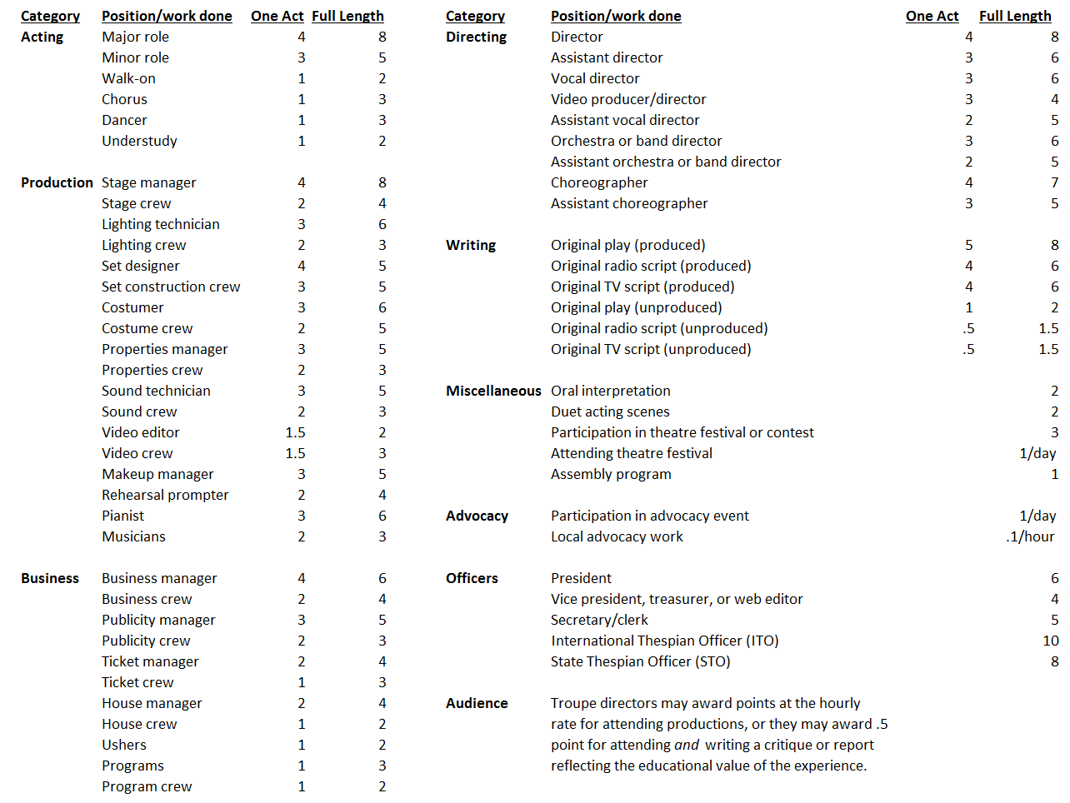

Thespian Honor Rank Summary
(see Thespian Troupe Handbook for details)
