Les Miserables Crew

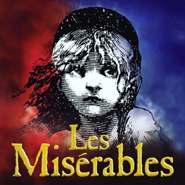

Stage Manager – Brooklyn Enriquez
Assistant Stage Managers – Hannah Harsey and Ethan Furlong
Lights
Matt Condon –12th Lead
Logan Sanders – 10th
Tressa Reynard – 9th
Joanna Fitzpatrick – 9th
Lyndsey Goldring – 9th

Sound
Carter Lantz – 11th - Lead
Savannah Marshall – 12th - Lead
Alexis Evans – 10th
Colin King – 10th

Costumes
Gwen Mitrevski –12th - Lead
Lily Ackerman- Coelho – 12th - Lead
Samantha Morgan – 10Th (will help with make-up too)
Hannah Gaertner* – 9th – Online right now

Make-up/Hair
Sophie Wehr – 12th - Lead
Hallie Anderson – 12th (also in cast(
Olivia Cheselske* (Online only for now)
Sidney Foster* (Online only for now)
Riya Khetarpal – 12th (also in cast)
Sophia Miller – 9th
Sydney Richmond – 12th
Sienna Rodriguez – 9th

Props/Publicity
Eowyn Wagner –10th - Lead
Reilly Brown – 9th
Tess Darby – 10th
Riley Harsey – 10th
Malia Marshall – 10th
Jane Putnam – 10th
Elena Quintero – 1^{0th} – Will be gone for 5 weeks
Sara Sims – 9th

Set
CJ Kadell –12th - Lead
Ethan Furlong – 9th
Gigi Gallo – 9th
Paula Guitierrez – 11th
Hannah Harsey – 10th
Armando Polanco – 9th
Susannah Poteet – 9th
Logan Ruby – 10th
Christian Ward – 10th

