Guys and Dolls Cast List
Runyonland Opener –many fun featured bits – TBA - from ensemble
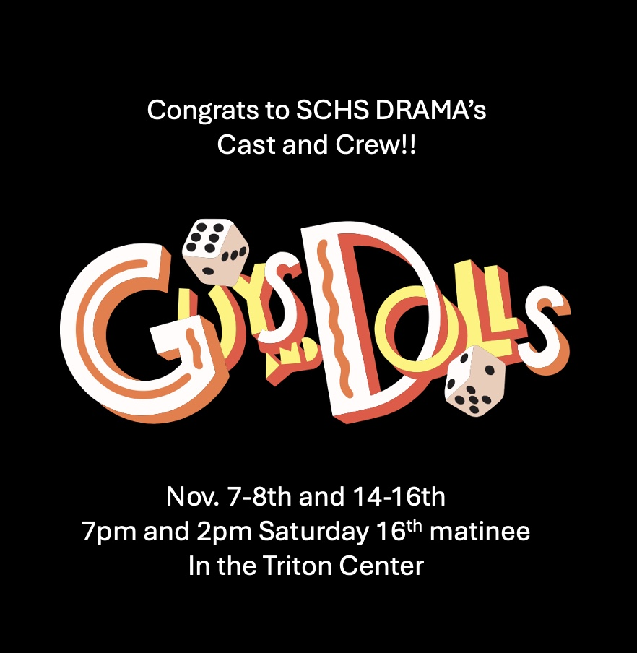
Gamblers
Nathan Detroit – Dylan Johnson
Sky Masterson – Will Turner
Nicely-Nicely Johnson – Duilio Ramirez
Benny Southstreet – Brandon Berube
Rusty Charlie/Another Player – Ryan Cochrun
Harry the Horse – Thelo du Halgouet
Angie the Ox/Player – Evan Potwora
Big Jule – Andrew Pollock
Crapshooters –Mahault du Halgouet, Aleia Fabio, Bella Hoyt, Jay Monareng, Hailey Reagles, Holland Thomas, Cole Wilkes
Joey’s voice (Joey Biltmore) – Evan Potwora
Lt. Brannigan – Derek Herrmann

Hot Box
Adelaide – Avery Santore
Adelaide understudy – Kaitlyn Finnigan – will perform role at matinee
Mimi – Mia Smith
Allison – Myla Pert
Ferguson – Hannah Pearson
Vernon – Kaitlyn Finnigan
Dancer #5 – Sophia Howard
Dancer #6 – Ava DiNicola
Dancer #7 – Faith Lund
Dancer #8 – Halle Browning
Master of Ceremonies – Kaia Miyasaki
Waiter – Derek Herrmann
Patrons of Hot Box – Ryan C., Thelo du H., Andrew P., Evan P., Cole W.

Mission Band Members/Salvation Army
Sarah Brown – Ella Corbridge
Sarah Brown understudy – Emalia Probert – will perform role at matinee
Arveena Abernathy – Sydney Ingersoll
Agatha – Emerson Donnellan
Calvin – Dylan Law
Martha – Gabby Miller
Members of Band – Parker Contreras, Emalia Probert, Karina Hutchinson, Ella Kane
General Cartwright – Kaia Miyasaki

Havana Scene
Stewardess – Parker Contreras
Male Cuban Dancer – Thelo du Halgouet
Featured Dancers - TBA
Bartender – Derek Herrmann
Head Waiter – Cole Wilkes

